Home Automation Systems

# Idea

In the inevitable future, home maintenance and improvement stores will begin selling home automation systems and all the devices, tools and hardware needed to modify and maintain them. At least we will see an extra shelf section next to the RJ11 / RJ45 products. It feels like a consumer market that is about to “come online” at stores near us.

In the physical world, home automation systems will always be a series of nested systems with standard device interfaces. Most likely there will be a separate network for higher security systems.

In 2013 I was excited by the idea of a “Smartgadget” that ran apps downloaded from an “App Store”. Like an Arduino with no programming cable. I was envisioning a simple, easy to use, highly adaptable home automation system. Today, I envision a more complex system where the “App” is downloaded from an “App Store” transferred to the main controller, transferred to the next controller, etc., until finally arriving at the target processor: where the “App” is programmed/installed/configured/…/used. Now abstract that.

The smartphone app is a marketplace gateway for an AI enabled ecosystem. We can put a black box in our garage that controls our sprinklers and buys data from the system next door because the home owner doesn’t want to buy additional sensors, etc. Black boxes buying and selling [objects of knowledge], with approval being the only human inputs. Also, imagine a home automation system app that helps you manage your home maintenance service providers. Of course, no money gets spent unless you click [approve]. But when you do: money is spent through an AI capable commerce channel. Imagine the economic possibilities. Can the black box in the garage be generating engineering drawings that people are requesting to buy from me?

In the future, will I be able to sell “AI enabled CAD tool outputs” through “AI capable commerce channels”?

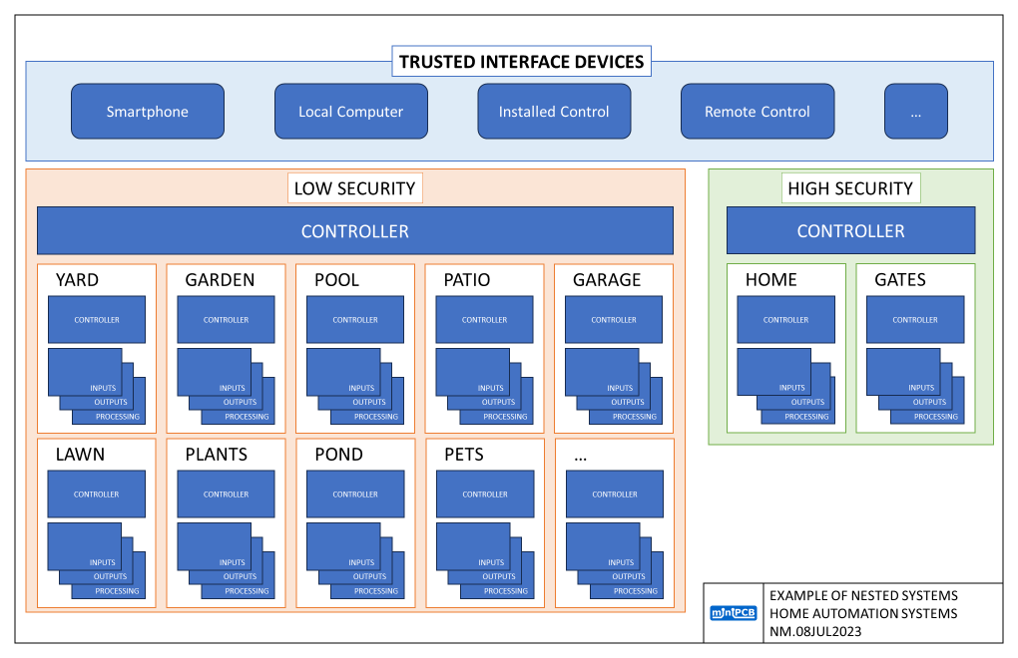

Products on the shelves will be:

* Devices to enable the network
  + RJ11, RJ45, wire, routers, multiplexers, etc.
  + Boxes, panels, conduits, connections, etc.
* Devices to connect to the network
  + Controllers, inputs, outputs, processors, interfaces, etc.
* Tools to modify and maintain the network
  + RJ11, RJ45, etc.
* Tools to install and service connected devices
  + Application specific tools and testers

THE REMAINDER OF THIS PAGE IS INTENTIONALLY BLANK.

The networks formed by the devices will be clustered around home-life solutions. Perhaps describable like this:

1. YARD
   1. LIGHTING
   2. PREMISES MONITORING
   3. CLIMATE MONITORING
2. LAWN
   1. WATERING
   2. FERTILIZING
   3. MOWING
3. GARDEN
   1. CLIMATE CONTROLLING
   2. NURTIRIENT CONTROLLING
   3. WATERING
   4. INSECT CONTROL
4. POOL
   1. FILLING
   2. PUMP
   3. FILTER
   4. SENSOR
   5. CONDITIONER
5. POND
   1. FILLING
   2. PUMP
   3. FILTER
   4. SENSOR
6. FOUNTAIN
   1. PUMP
   2. FILTER
   3. SENSOR
7. PATIO
   1. LIGHTING
   2. FAN
8. PLANT
   1. WATERING
   2. NUTRIENT MONITORING
9. PET UTILITY
   1. FOOD
   2. HEALTH
   3. PLAY
   4. WASTE
10. GARAGE
    1. ACCESS CONTROL
    2. PREMISES MONITORING
    3. LIGHTING
    4. BACKUP POWER
    5. SOLAR POWER
    6. VEHICLE CHARGING
    7. VEHICLE MONITORING
11. SHED
    1. ACCESS CONTROL
    2. PREMISES MONITORING
    3. LIGHTING
12. HOME
    1. ACCESS CONTROL
    2. PREMISES MONITORING
    3. SECURITY
    4. SAFETY
    5. ENERGY MONITORING
    6. WATER TREATMENT
    7. HVAC
    8. APPLIANCES
    9. LIGHTING
    10. ENTERTAINMENT
13. FARM
    1. EQUIPMENT MONITORING
    2. CLIMATE MONITORING
    3. IRRIGATION

# NM.08JUL2023

Can we make a simple-task simpler, by adding extreme complexity? Does it make sense?

Can we develop an AI enabled engineering setup to rapidly innovate in this area? Find the wealth wave.

What is inevitable development work? What can I do?

How can I prepare myself to do that [inevitable work] more efficiently when I get an AI enabled CAD?

How much value can one highly ambitious engineer create during my lifetime?

With AI enabled CAD, how far can I go with the miniPCB brand?

1. Sweep through hundreds of fundamental, classic, and creative circuits?
2. Sweep through dozens of instruments, tools, and toys?
3. Sweep through … a building automation system product space?

Continuing with EAGLE 9 may preclude many AI enabled CAD tools.

I might need to continue to struggle with EAGLE 6.

Is KiCAD a good CAD tool for making the transition to being AI enabled?

# Change and Liability Notice

This document is subject to change without notice. While effort has been made to ensure the accuracy of the material contained within this document, Nolan Manteufel shall under no circumstances be liable for incidental or consequential damages or related expenses resulting from the use of this document.

# Trademark Notice

miniPCB is a trademark of Nolan Manteufel.

This document does not constitute permission to use the miniPCB trademark.

|  |  |  |
| --- | --- | --- |
| WORDMARK | FIGUREMARK | FIGUREMARK |
| miniPCB™ | A picture containing drawing  Description automatically generated™ | Icon  Description automatically generated™ |

# Revision History

|  |  |  |  |
| --- | --- | --- | --- |
| REV | DESCRIPTION | ECO | DATE |
| A | Initial Release | N/A | 08JUL2023 |
|  |  |  |  |